FOR IMMEDIATE RELEASE
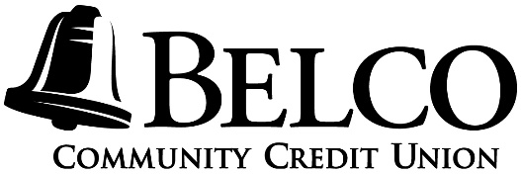
CONTACT:
Lisa M. Moyer
Belco Community Credit Union
Community Relations Coordinator
(800) 642-4482, Ext. 6415
moyerl@belco.org
www.belco.org

BELCO CELEBRATES 81 YEARS IN BUSINESS
Harrisburg, PA (March 5, 2020) – Belco Community Credit Union is proud to celebrate 81 years of service to central PA. Over the past 81 years many things have changed, but one thing that has remained is consistency of member service and value to the community.
Belco will celebrate its 81st Anniversary on Friday, March 6, at all 14 locations. Each Belco branch will offer free cake and a free gift. Belco will also be giving away five $81 Visa gift cards. During the month of March, members who open a new Visa credit card will receive a free Belco gift ($20 value).
Belco was formed as Pennsylvania was climbing out of the Great Depression and the world was preparing for war. On March 7, 1939, Elton “Miller” Peterman and 24 of his coworkers formed a federally chartered credit union to serve the employees of Bell Telephone Company of Harrisburg, PA. By 1941, membership had grown to 401. That early two-year growth marked the beginning of Belco’s journey to providing financial services through the generations. In 2005, Belco converted to a community charter in order to bring credit union benefits to more people in the area.
Currently, Belco has 14 branches and more than 67,000 members and $633 million in assets. Thanks to valued members, Belco continues to grow each year. You are eligible to join Belco if you live, work, worship, volunteer or attend school in Adams, Cumberland, Dauphin, Lancaster, Lebanon, Perry and York counties.

# # #

About Belco Community Credit Union
Belco Community Credit Union is a full-service financial institution offering checking, savings, loan, investment and small business products and services. Established in 1939 to serve employees of Bell Telephone Company in Harrisburg, PA, Belco became a community chartered credit union in July 2005, opening membership to businesses and individuals who live, work, worship, or attend school in Adams, Cumberland, Dauphin, Lancaster, Lebanon, Perry and York counties. Belco currently has 67,000 members and $633 million in assets, 14 branches, numerous ATM locations, and 24-hour account access through mobile, online and telephone banking. For more information, visit www.belco.org or call (800) 642-4482.

